Stand-Up Shamrock
In this simple project, cardboard from a cereal box and a toilet paper tube are turned into a cute free-standing shamrock that is great to use as a St. Patrick's Day decoration.

Supplies needed:  - Green cardstock or cardboard from a cereal box (or other stiff paper)  - A tube from a roll of toilet paper  - Green paint  - Brush  - Scissors  - Optional: glitter, markers, googly eyes, etc. | 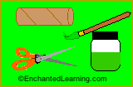

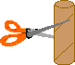 | Cut the toilet paper tube in half, creating a short cylinder (roughly 2 inches tall). Each stand-up shamrock needs half a tube.
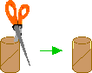 | On the half-tube, cut two 1/2 inch slits, one on each side (this is where you will insert the paper shamrock).
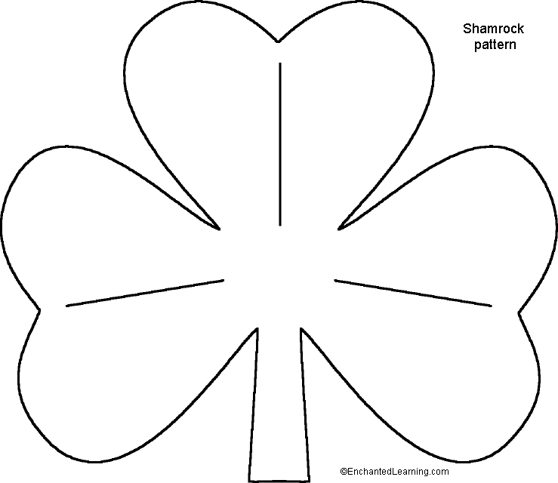  Shamrock Template | Using stiff cardboard (for example, from a cereal box), cut out a large shamrock.
 | Paint the shamrock and the tube green. Let them dry.
When the paint is dry, add decorations to the shamrock if you like (for example, details made with markers, glitter, googly eyes, etc.). And don't forget to sign it.
Insert the shamrock into the slits in the tube. You now have your own free-standing shamrock to help you celebrate St. Patrick's Day.

