Handprint Bunny
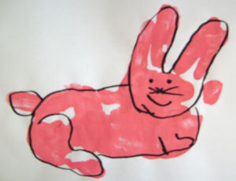
Here's a cute handprint bunny that the kids can print in a flash! Only one colour to clear up, too.
You will need:
Pink paint
Paper
Black pen
Instructions:
Print a horizontal handprint, fingers together in the middle of the page, with the thumb at the bottom.
Print a vertical handprint overlapping the palm with the fingers of the first print.
Make your fingers into a ‘V’ shape between the middle and ring fingers to make the two ears.
Add a thumbprint tail and leave to dry.
Outline with black pen, and add features.

