Pine Cone Bird Feeder
A easy-to-make Pine Cone Bird Feeder. This is a simple project that even young children can help make.
For each Pine Cone Bird Feeder you will need:
- A large, open pine cone  - Vegetable shortening, lard or suet  - Oats or corn meal  - Bird seed  - A few feet of string | 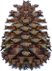

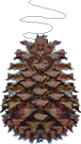 | Tie a few feet of string to a pine cone. Cover the pine cone with the mixture below. Roll the pinecone in birdseed and then suspend it from a tree branch outside.  Food mixture: Mix 1/2 cup vegetable shortening, lard or suet with 2 1/2 cups cornmeal or uncooked oats until well blended. Optional: add dried fruit (chopped up), chopped nuts, seeds (especially sunflower and millet), and/or suet, which are high-energy bird foods. | 